Branch name:
fatmah-task
Pull Request link:
https://github.com/longlinht/intern-git-practice-lab/pull/2
Summary:
I completed the Summer Internship Git Practice Project by creating my own branch and updating all required files. I added a clearer project purpose in the README, included my intern information, wrote a detailed robot startup checklist, added professional safety rules, updated the Python script with output messages, added .gitignore entries, and wrote a daily log for the completed work. I also committed the changes, pushed my branch to GitHub, and opened a pull request.
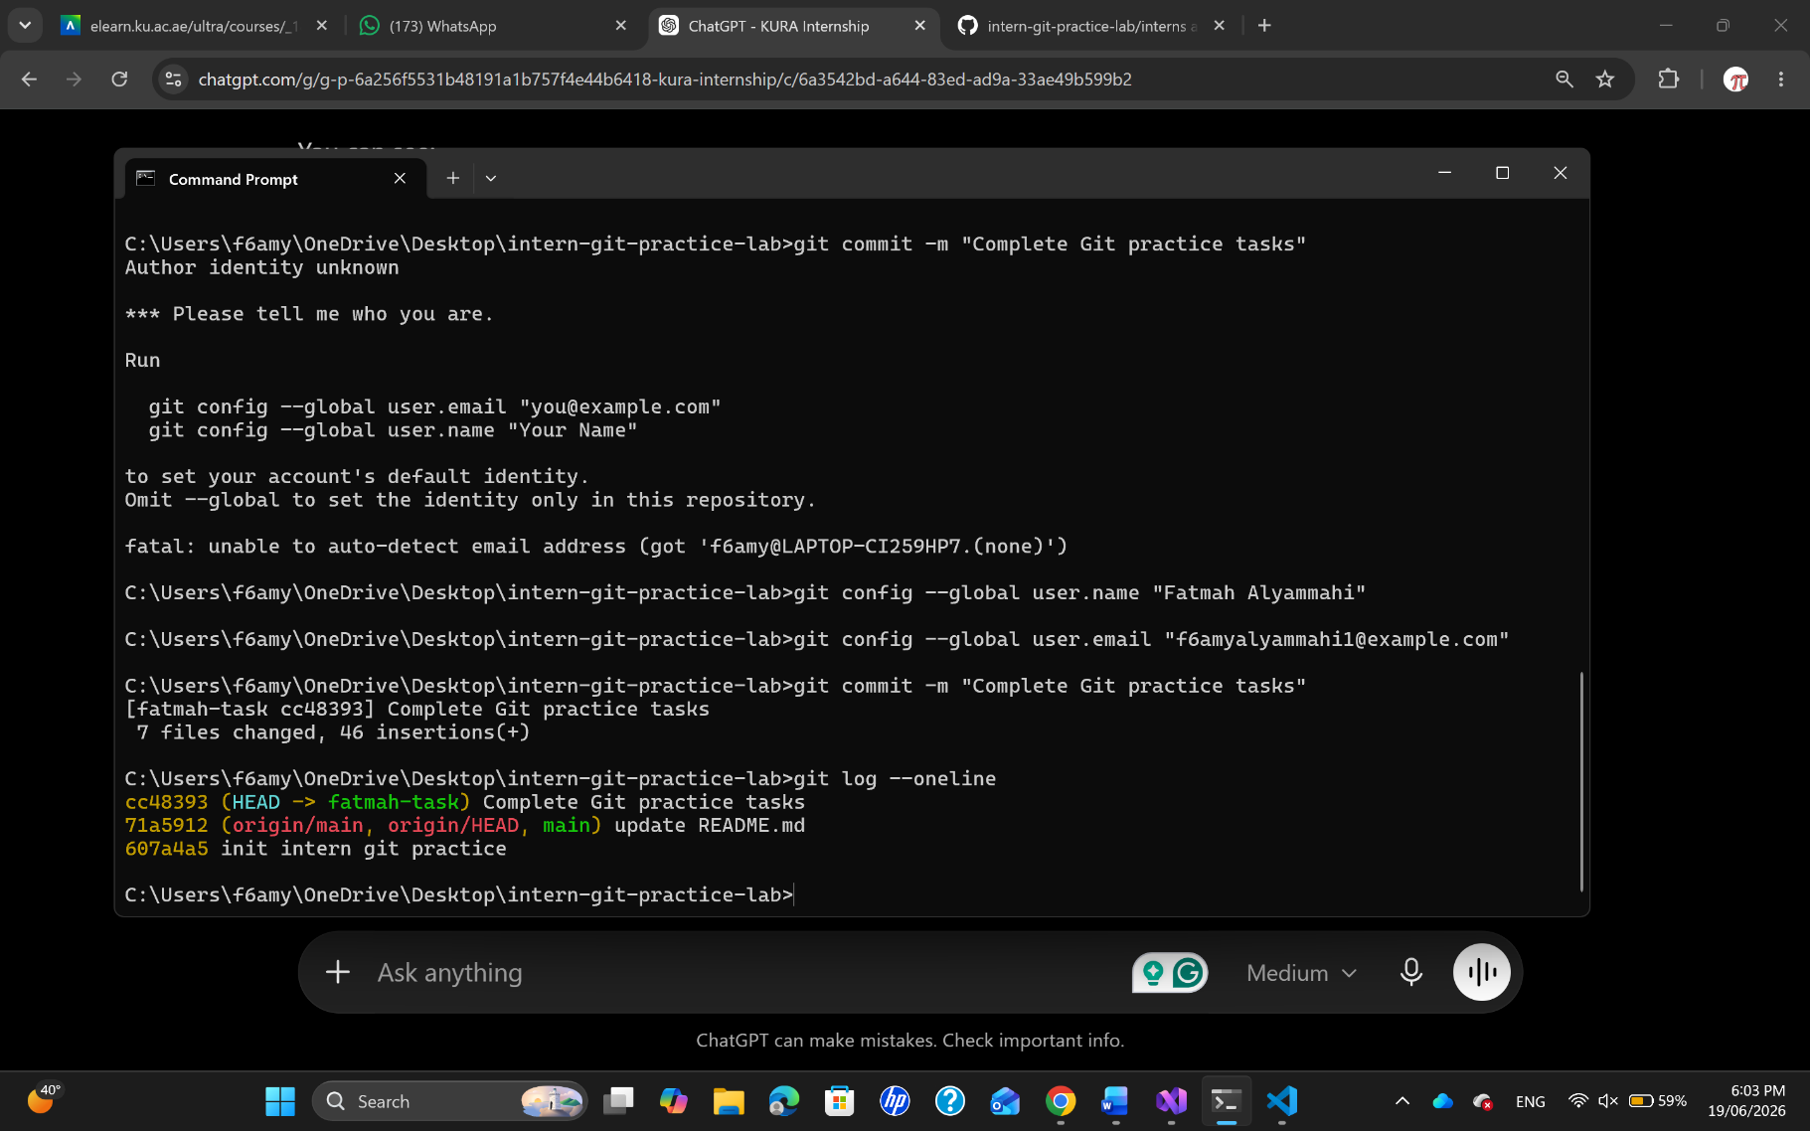
I also attached a screenshot of the commit history from git log --oneline.

